**Experiment No: 1 Date: 21/03/2024**

**FAMILIARISATION OF COMPUTER HARDWARE**

**AIM**

Understand about components of Computer Hardware

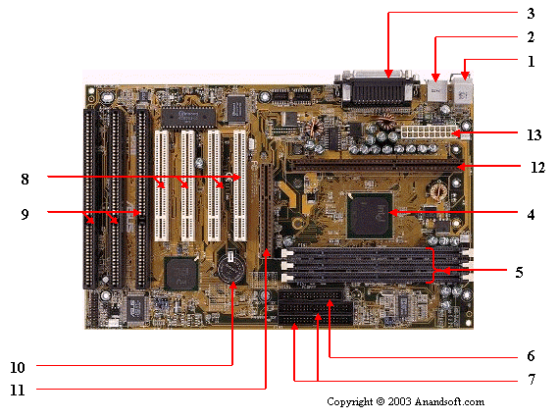

1. Mouse & keyboard

2. USB

3. Parallel port

4. CPU Chip

5. RAM slots

6. Floppy controller

7. IDE controller

8. PCI slot

9. ISA slot

10. CMOS Battery

11. AGP slot

12. CPU slot

13. Power supply plug in

1. Mouse & keyboard: Keyboard Connectors are two types basically. All PCs have a Key board port connected directly to the motherboard. The oldest, but still quite common type, is a special DIN, and most PCs until recently retained this style connector. The AT-style keyboard connector is quickly disappearing, being replaced by the smaller mini DIN PS/2-style keyboard connector.

You can use an AT-style keyboard with a PS/2-style socket (or the other way around) by using a converter. Although the AT connector is unique in PCs, the PS/2-style mini-DIN is also used in more modern PCs for the mouse. Fortunately , most PCs that use the mini-DIN for both the keyboard and mouse clearly mark each mini-DIN socket as to its correct use. Some keyboards have a USB connection, but these are fairly rare compared to the PS/2 connection keyboards.

2. USB (Universal serial bus): USB is the General-purpose connection for PC. You can find USB versions of many different devices, such as mice, keyboards, scanners, cameras, and even printers. a USB connector's distinctive rectangular shape makes it easily recognizable.

USB has a number of features that makes it particularly popular on PCs. First, USB devices are hot swappable. You can insert or remove them without restarting your system.

3. Parallel port: Most printers use a special connector called a parallel port. Parallel port carry data on more than one wire, as opposed to the serial port, which uses only one wire. Parallel ports use a 25-pin female DB connector. Parallel ports are directly supported by the motherboard through a direct connection or through a dangle.

4. CPU Chip : The central processing unit, also called the microprocessor performs all the calculations that take place inside a pc. CPUs come in Variety of shapes and sizes.

Modern CPUs generate a lot of heat and thus require a cooling fan or heat sink. The cooling device (such as a cooling fan) is removable, although some CPU manufactures sell the CPU with a fan permanently attached.

5. RAM slots: Random-Access Memory (RAM) stores programs and data currently being used by the CPU. RAM is measured in units called bytes. RAM has been packaged in many different ways. The most current package is called a 168-pin DIMM (Dual Inline Memory module).

6. Floppy controller: The floppy drive connects to the computer via a 34-pin ribbon cable, which in turn connects to the motherboard. A floppy controller is one that is used to control the floppy drive.

7. IDE controller: Industry standards define two common types of hard drives: EIDE and SCSI. Majority of the PCs use EIDE drives. SCSI drives show up in high end PCs such as network servers or graphical workstations. The EIDE drive connects to the hard drive via a 2-inch-wide, 40-pin ribbon cable, which in turn connects to the motherboard. IDE controller is responsible for controlling the hard drive

8. PCI slot: Intel introduced the Peripheral component interconnect bus protocol. The PCI bus is used to connect I/O devices (such as NIC or RAID controllers) to the main logic of the computer. PCI bus has replaced the ISA bus.

9. ISA slot: (Industry Standard Architecture) It is the standard architecture of the Expansion bus. Motherboard may contain some slots to connect ISA compatible cards.

10. CMOS Battery: To provide CMOS with the power when the computer is turned off all motherboards comes with a battery. These batteries mount on the motherboard in one of three ways: the obsolete external battery, the most common onboard battery, and built-in battery.

11. AGP slot: If you have a modern motherboard, you will almost certainly notice a single connector that looks like a PCI slot, but is slightly shorter and usually brown. You also probably have a video card inserted into this slot. This is an Advanced Graphics Port (AGP) slot.

12. CPU slot: To install the CPU, just slide it straight down into the slot. Special notches in the slot make it impossible to install them incorrectly. So remember if it does not go easily, it is probably not correct. Be sure to plug in the CPU fan's power.

13. Power supply plug in: The Power supply, as its name implies, provides the necessary electrical power to make the pc operate. the power supply takes standard 110-V AC power and converts into 12-Volt, 5-Volt, and 3.3-Volt DC power.

**RESULT**

Understood the components of Computer Hardwares

**Experiment No: 2 Date: 28/03/2023**

**INSTALLATION OF VIRTUAL MACHINE**

**AIM**

Installation steps of virtual machine in the system

1.Start the virtualbox application

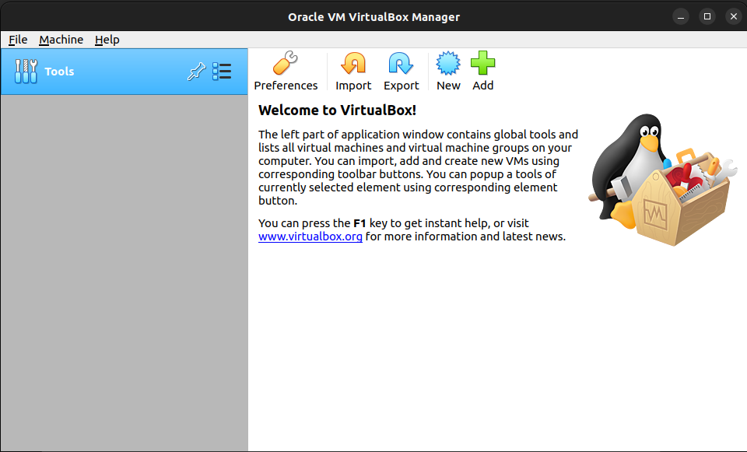

2. Click on new and fill the necessary details and click next

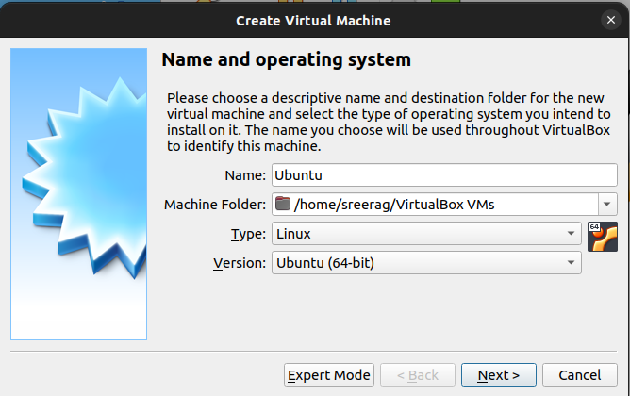

3. Give the RAM size as above 4 GB and click next

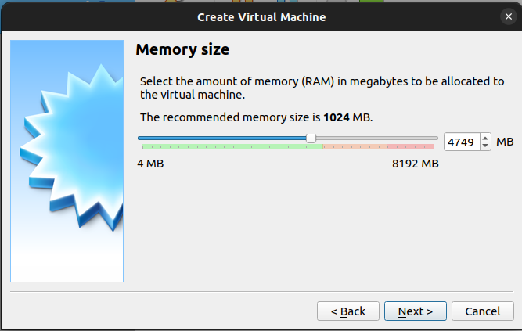

4. Select the option create a virtual hard disk now and click create

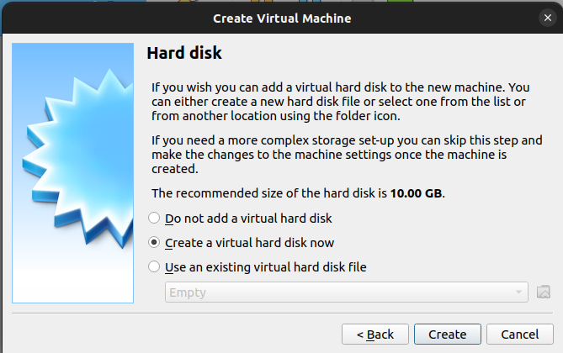

5. Select the option VDI and click next

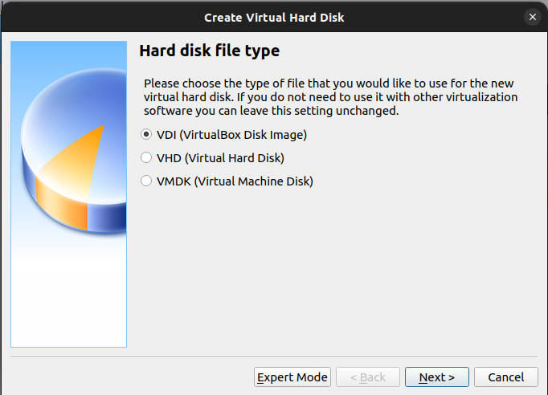

6. Select the option Fixed size and click next

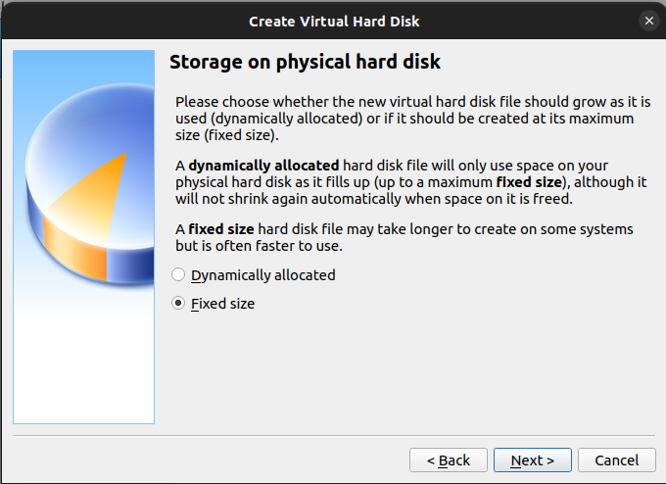

7. Select the memory size as 100 GB for the OS partition and click create

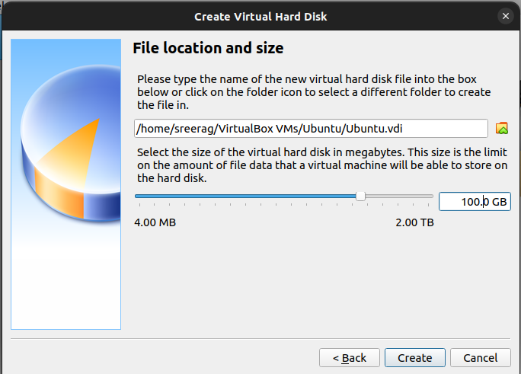

8. Click on start by selecting the OS from left side.

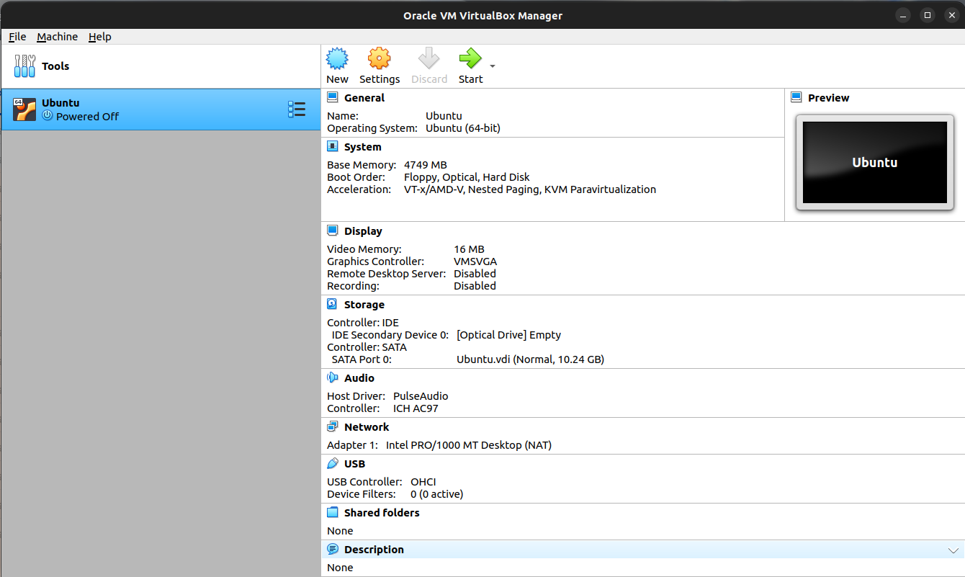

9. Click on the file button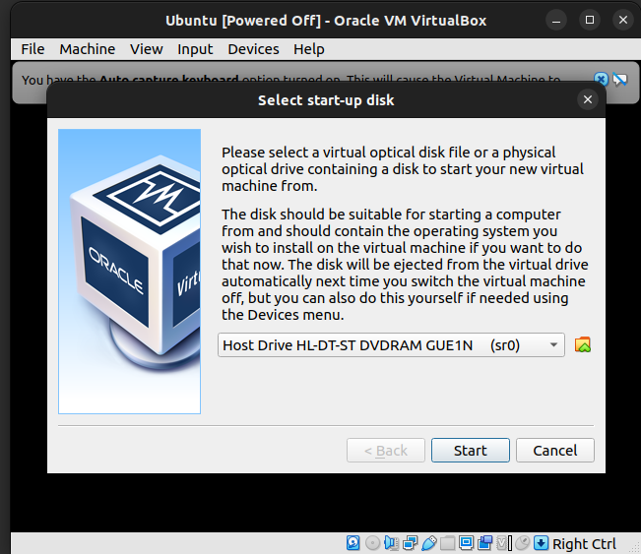

10. Select the ISO file by clicking add. And click on choose

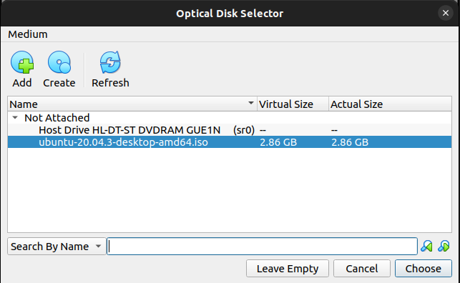

11. Start with installation of selected OS and use it once the installation is done.

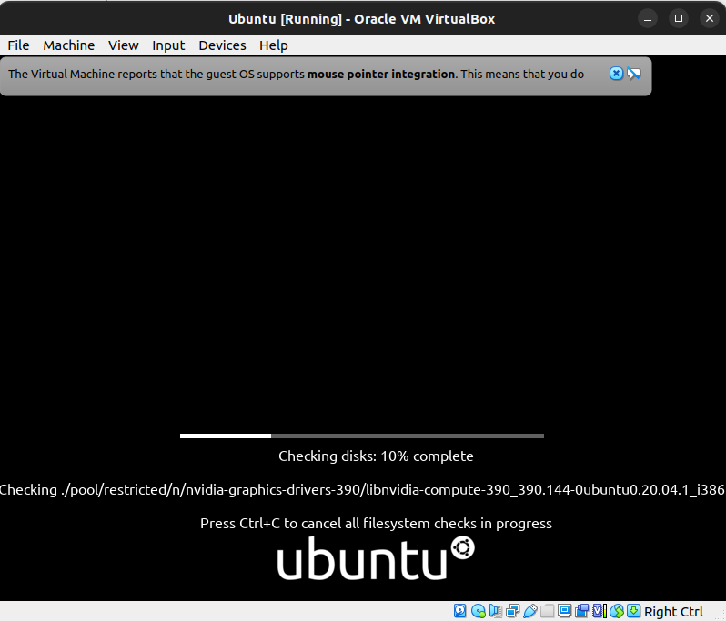

**RESULT**

Understood the steps for installing the virtual box.

**Experiment No: 3 Date: 04/04/2023**

**LINUX FILE SYSTEM HIERARCHY**

**AIM**

Understand the different Linux File System and its Hierarchy

The Linux File System Hierarchy Standard (FSH) defines the organization and structure of files and directories in a Linux-based operating system. It provides a consistent and standardized way to organize system files, configuration files, libraries, binaries, and other resources. The following is a brief overview of the main directories in the Linux File System Hierarchy:

/ (root):

The root directory is the top-level directory in the file system hierarchy. It contains all other directories and files.

/bin:

This directory holds essential executable files that are required for the system to boot and run, accessible to all users.

/boot:

The /boot directory contains files necessary for booting the system, such as the Linux kernel, bootloader configuration, and initial RAM disk (initramfs).

/dev:

This directory contains device files that represent hardware devices or pseudo-devices. It allows direct access to various hardware devices.

/etc:

The /etc directory contains system-wide configuration files, such as network settings, user account information, and startup scripts.

/home:

Each user on the system has a dedicated subdirectory under /home, which serves as their home directory. Users can store personal files and configuration here.

/lib and /lib64:

These directories contain libraries that are essential for the system and various programs to run. The /lib directory is used for 32-bit libraries, while /lib64 is for 64-bit libraries.

/media:

The /media directory is used as a mount point for removable media devices, such as USB drives or optical discs.

/mnt:

The /mnt directory is a generic mount point for temporarily mounting file systems or other devices.

/opt:

The /opt directory is used for installing optional software or third-party applications. Each application typically has its own subdirectory here.

/proc:

The /proc directory provides a virtual file system that contains information about running processes and system configuration. It allows access to system information through special files.

/root:

The /root directory is the home directory for the system's root user (superuser). It is different from /home/root, which would be a separate directory for a user named "root."

/sbin:

Similar to /bin, the /sbin directory contains essential system binaries. However, the binaries in /sbin are typically meant for system administration tasks and require administrative privileges.

/srv:

The /srv directory is used for storing data files related to services provided by the system. It may include files for web servers, FTP servers, or other network services.

/tmp:

The /tmp directory is used for temporary files created by various programs and users. The files in this directory are usually deleted upon system reboot.

/usr:

The /usr directory contains most of the user-readable, non-system-critical files. It includes subdirectories like /usr/bin (user binaries), /usr/lib (user libraries), /usr/share (shared data), and more.

/var:

The /var directory holds variable files that frequently change during system operation, such as log files, spool files (for printing), and temporary files generated by system processes.

**RESULT**

Understood the Linux File System Hierarchy

**Experiment No: 4 Date: 11/04/2023**

**FAMILIARISATION OF LINUX COMMANDS**

**AIM**

Execute the basic Linux commands.

1. Command to display the following message as such (Use ” and Newline).

"Hi Everyone..

We are starting Shell Scripting"

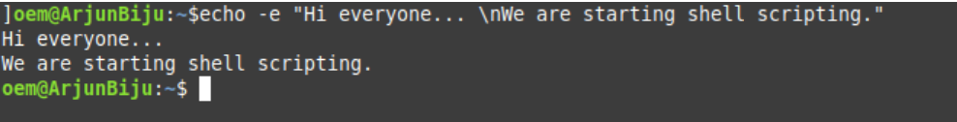

2. Read your name from the keyboard and display it.

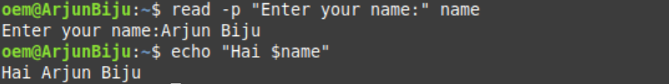

3. Create the directory structure dir1/dir4 and dir1/dir2/dir3 with a single command and then change directory to dir3



4. Create a file testfile1 using nano.

Display the file

(i) starting with the first 10 lines and

(ii) starting with the 10th line with provision for

a) Scrolling Up

b) Scrolling Up and Down



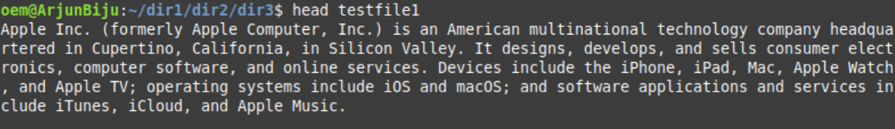

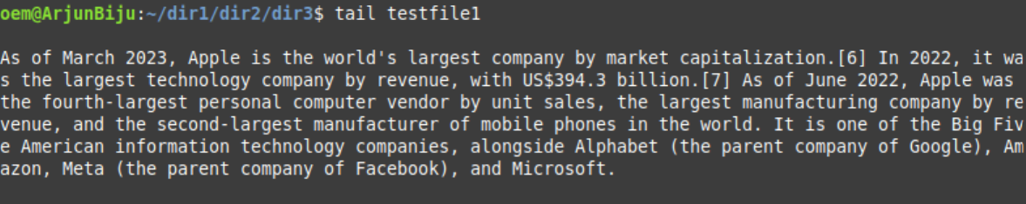

5. Get the manual page of ’ls’ command. Search for the word ”alphabetic”. Find the next occurrence and then find the previous occurrence.





6. Create 2 files testfile2 and testfile3 using nano.

(a) Modify the permissions of testfile2 using symbolic mode

i. Add read permission to others

ii. revoke write from owner

iii. set only execute to Group.

iv. add write to owner, revoke read from others and set read only to group.

v. set read and write to all

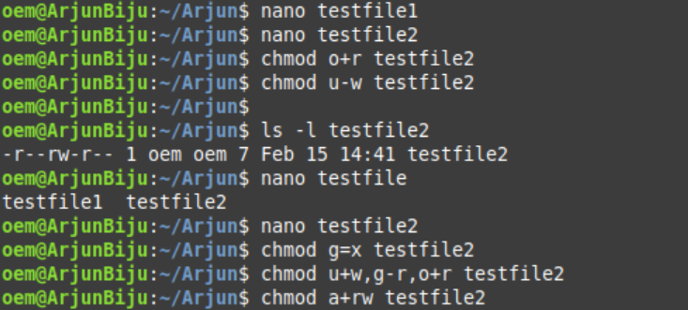

(b) Modify the permissions of testfile3 using numeric mode

i. Set read and write to all

ii. set read, write and execute to owner, read and execute to group and read only to others

(c) Set the permissions of testfile2 the same as that of testfile3

(d) Set the permissions of the tree (the directory, its children , grandchildren, etc.) rooted at dir1 (Qn. 3) directory to 664

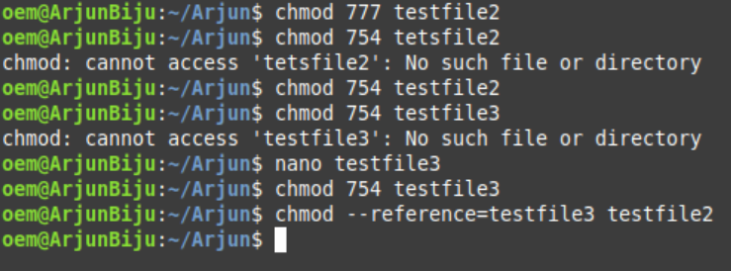

7. Change the owner and group of the directory tree from dir2 to student.



8. Display the current directory



9. Listing Files and folders

(a) List the contents of dir1 (Qn. 3) and all its descendants

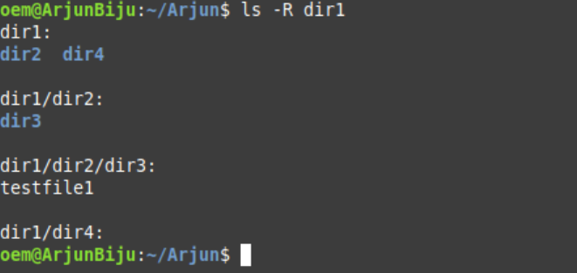

(b) List the contents of dir3 (Qn. 3) in

1. Alphabetical Order

2.Sorted on Time of modification, newest first

3.Sorted on Size

4.Reverse of all above

5.Long listing of files Sorted on Size with smallest first and size

6.displayed in human readable form

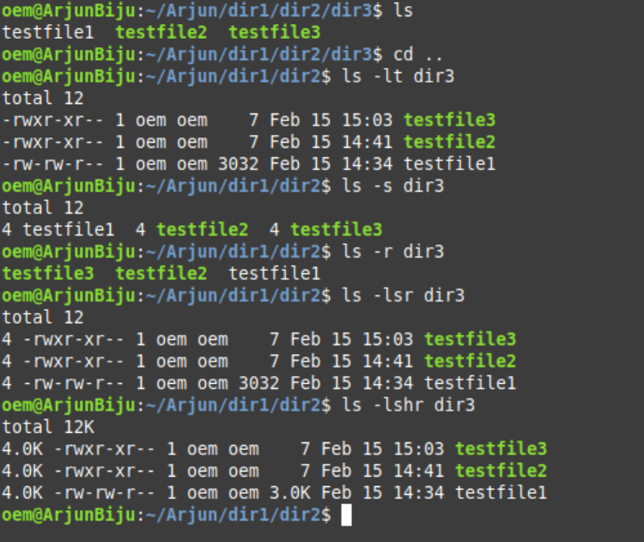

10. (a) Execute ls and store the output to a file lsoutput

(b) Execute ls -l and add the output to lsoutput, at the end.

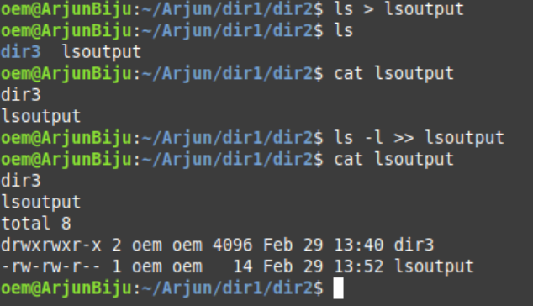

11. Execute ls -l and feed the result to less command, to scroll through the directory listing.

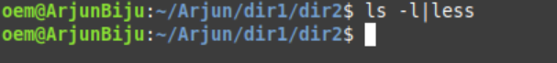

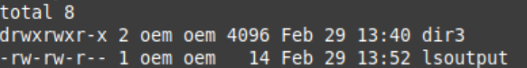

12. (a) Create a file file1 containing the word ”Hello,” using cat and output redirection

(b) Create another file file2 containing the word ”, Greetings!!”

(c) Display the sentence,

Hello,

Your name, Greetings!!

using cat, by concatenating file1, Standard Input and file2

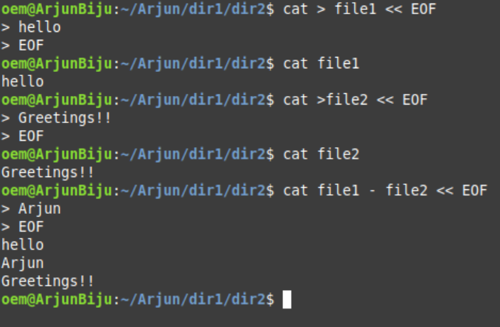

13.. Copy the file file1 to newfile.

(a) If newfile already exists, it should be replaced.

(b) If newfile already exists, it should not be replaced.

(c) If newfile already exists, it should be replaced, but only with the consent of the user.

(d) If newfile already exists, it should be replaced only if its contents is older than that of newfile.

(e) Even if newfile is read only.

(f) Create a link instead of copying.

(g) Copy the entire directory tree from dir1 of Cycle 1 to a new directory dir5

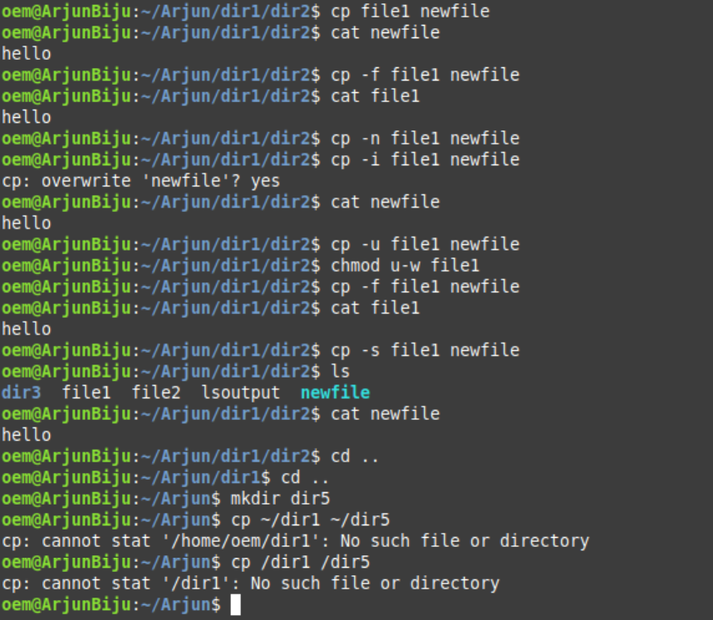

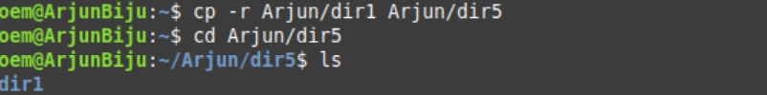

14. Create a new directory, dir6 inside dir1

(a) Move all files in dir5 into it.

(b) Rename the file newfile in Qn.4 to oldfile

(c) Move the file file1 in Qn.4 to dir6 with the name file3

(d) Delete all files where name starts with a vowel character, upper or lower case.

(e) Delete all files where the name is at least 3 characters long.

(f) Delete all hidden folders, and files.

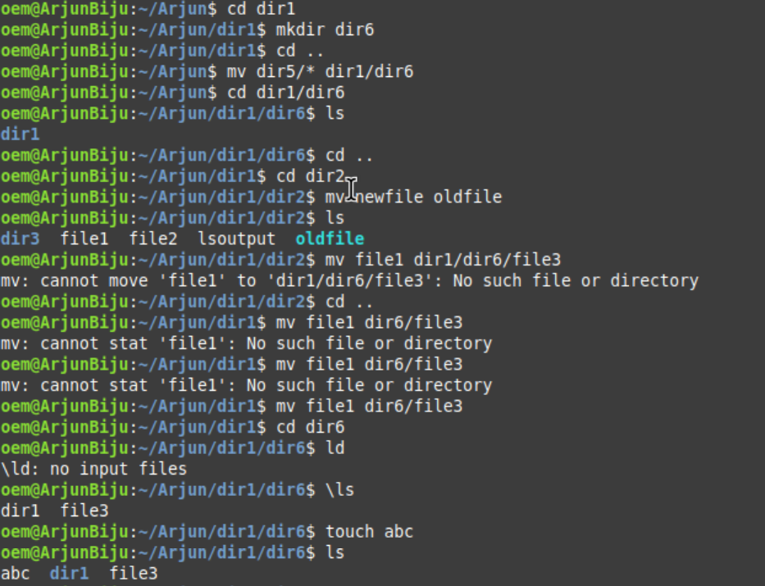

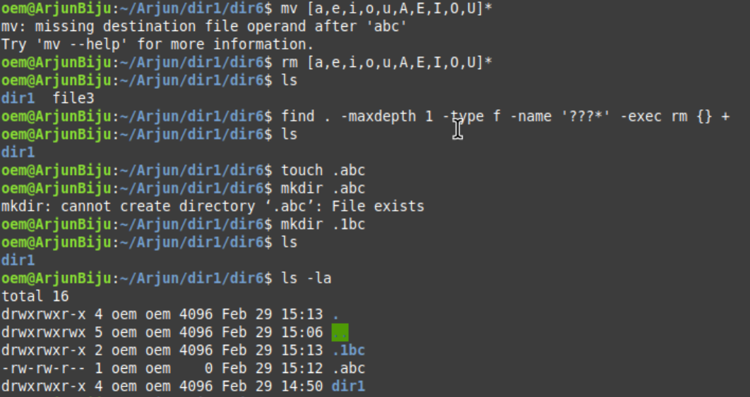

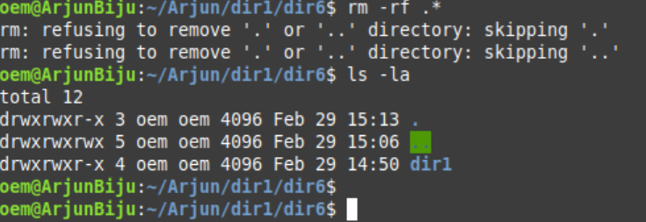

15. Using cut filter

(a) Display the filenames from ls -l assuming filenames start at column 50.

(b) Display user Id and user name of all users from /etc/passwd. (fields 1 and 3)

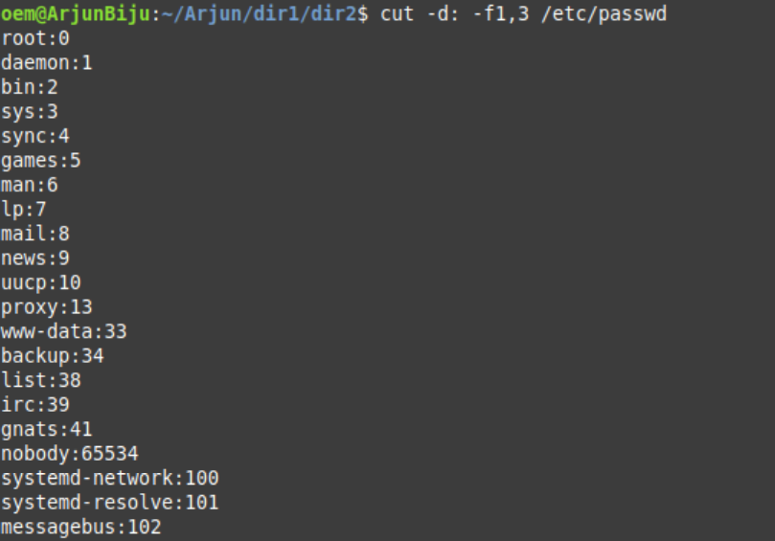

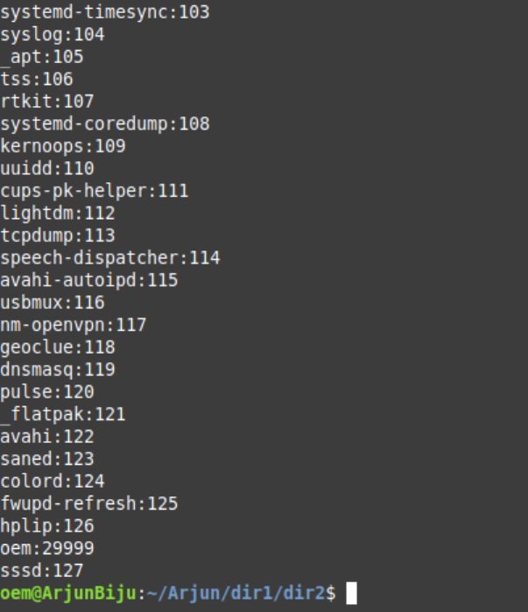

16. Create 3 files containing name, age and marks of 5 students respectively and paste them into a single csv (comma separated values) file.

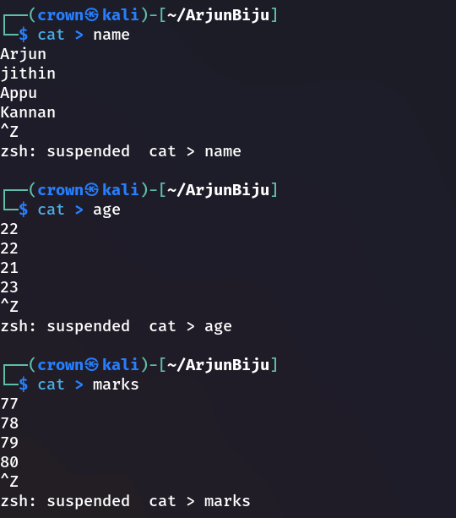

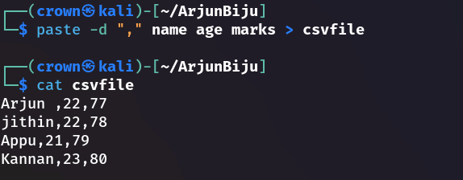

17. Using find

(a) piped with wc, display the number of files in a directory that starts with the letter a

(b) Delete all .c files in the parent directory

(c) Copy all files that starts with a to dir2

(d) Display files in the current directory that were modified in the last 30 minutes.

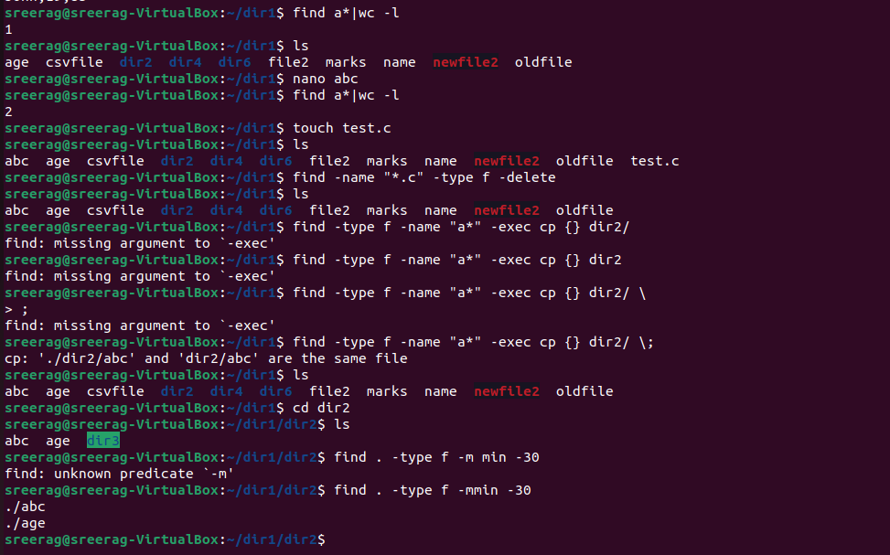

18. Use head and tail piped with cat /etc/passwd to display the details of

(a) The first 12 users in the system.

(b) The last 7 users in the system.

(c) All but the first 3.

(d) All but the last 5.

(e) Only the 9 th .

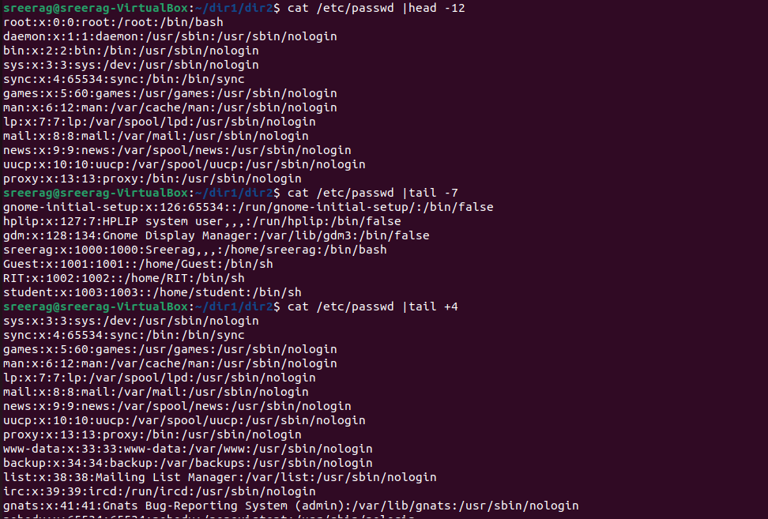

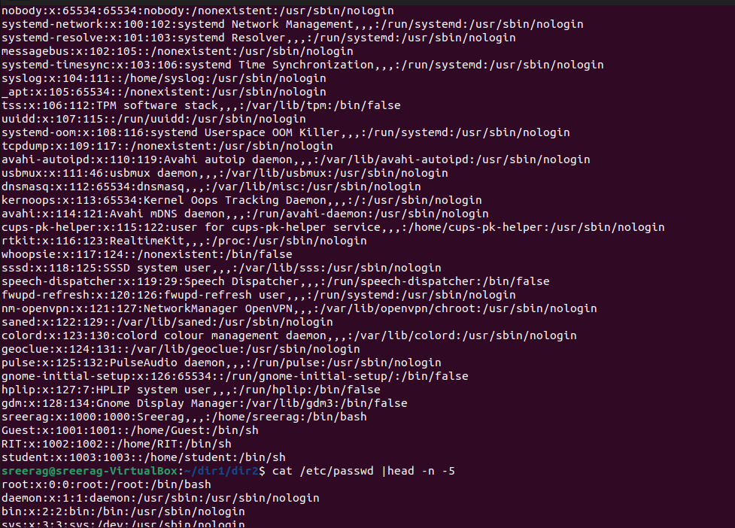

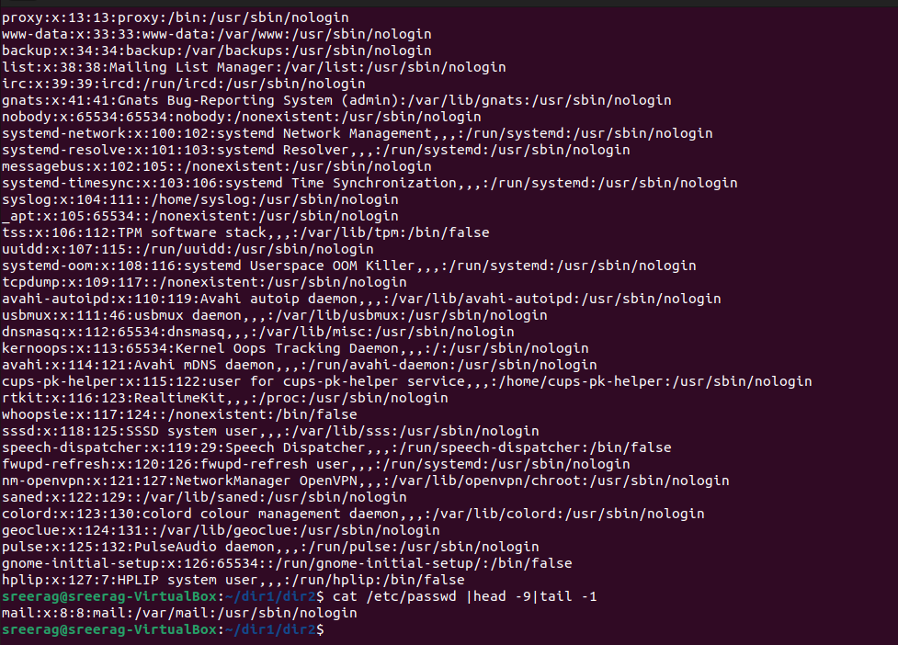

19. Use grep to

(a) Display all lines in a file that contains the string abc

(b) Display all lines in a file that does not contain the string abc

(c) List names of all .c files that contains a printf

(d) List names of all .c files that does not contain a printf

(e) Display the number of #include statements in each .c file.

(f) Display the Line numbers of printf in a .c file.

(g) List names of all files in the directory tree that contain a printf.

(h) Display the context of every printf in a .c file. i.e., n lines before and after every printf.

(i) ls -l starts with d for directories. Use ls -l piped with grep & cut to display the names of all directories in the current directory.

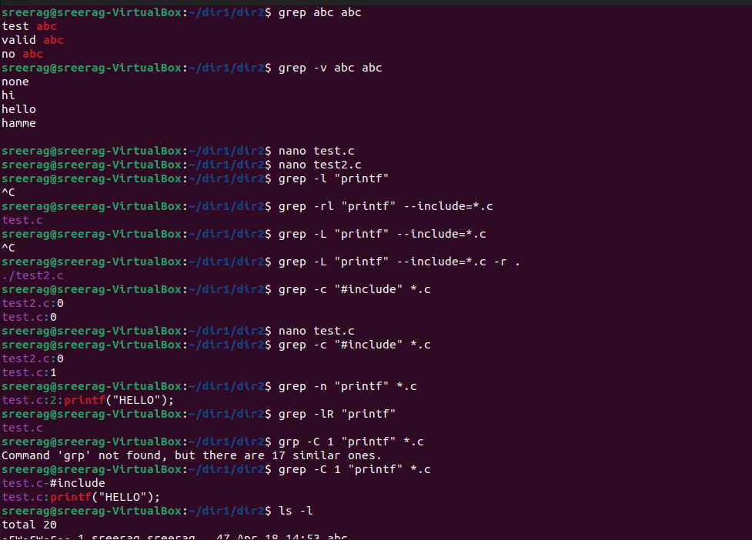

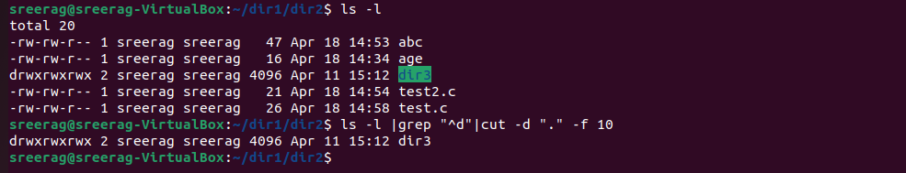

20. Using expr

(a) Read two integers X and Y . Display the sum, difference, product, quotient and remainder of these variables.

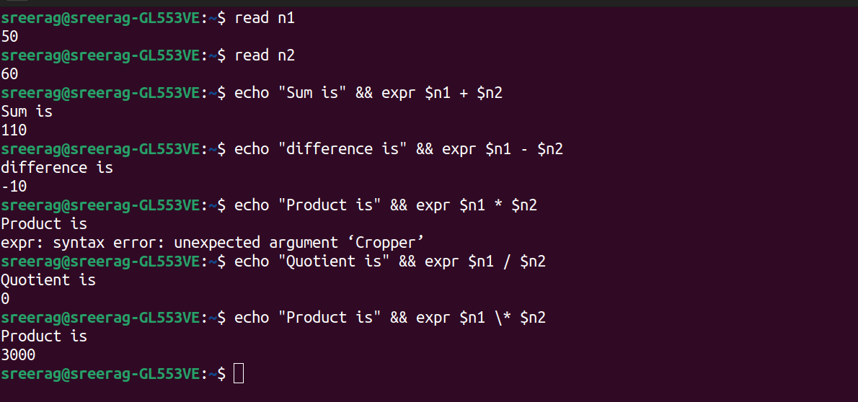



(b) Read a string, S, a position, p and a length l. Display the substring of length l starting at position p from the string S

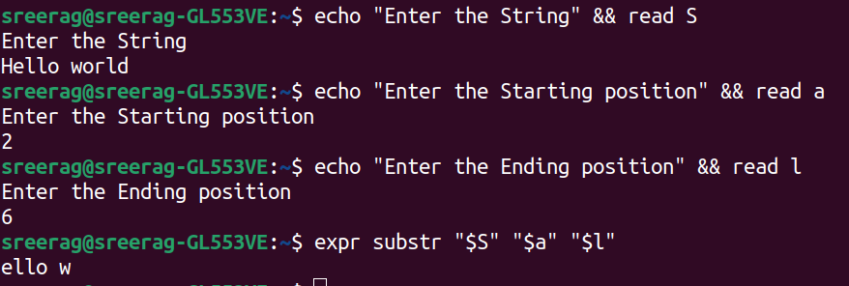

**RESULT**

Basic Linux commands has been executed and the output is verified.